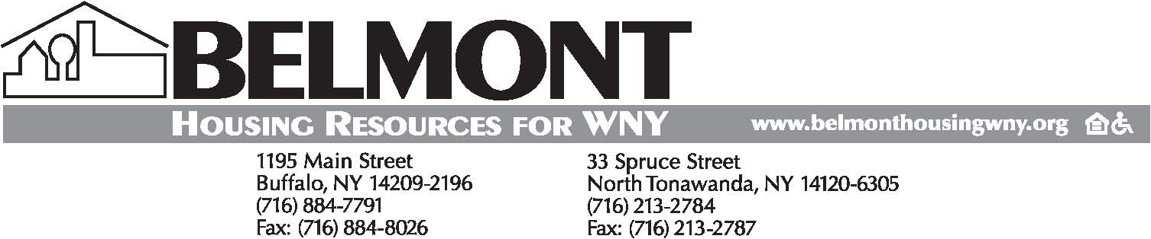

Dated 5/6/2016

EMPLOYMENT OPPORTUNITY

Founded in 1977, BHR is a leading advocate for quality affordable housing. We administer rental assistance programs and offer a variety of housing-related programs and services promoting home ownership, educating renters and landlords, improving existing housing stock, and developing and managing affordable housing.

HOUSING SPECIALIST – Service-oriented individual with strong math, verbal, writing, organizational and time management skills needed to administer rental assistance programs for low-income families at our Buffalo office. This individual will assist clients with housing searches and conduct income determinations for the program participants to determine continued eligibility. Must maintain accurate computer records and files. Bilingual a plus.
Requirements: Bachelor's degree OR a four year combination of education and experience.

Submit resume and cover letter online at: www.belmonthousingwny.org/employment

Deadline to Apply is May 18, 2016

Belmont Housing Resources for WNY is an Equal Opportunity Employer and strong advocate of workforce diversity. Minority/Female/Sexual Orientation/Gender Identity/Disability/Veteran

