**For New Users: Search Openings & Create a Profile**

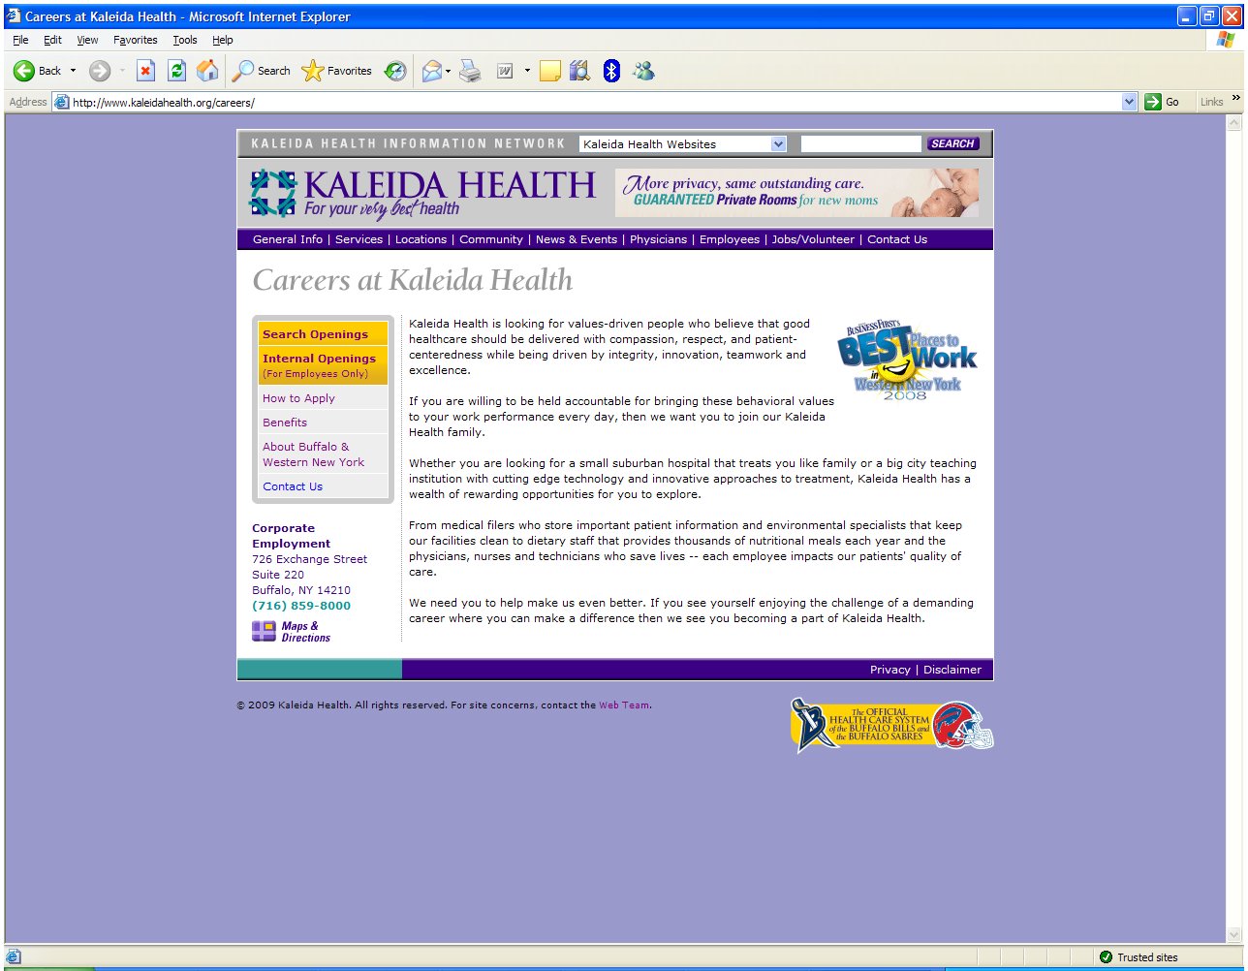

Go to our website at [www.kaleidacareers.org](http://www.kaleidacareers.org).

Click on ***Search Openings*** to get started.

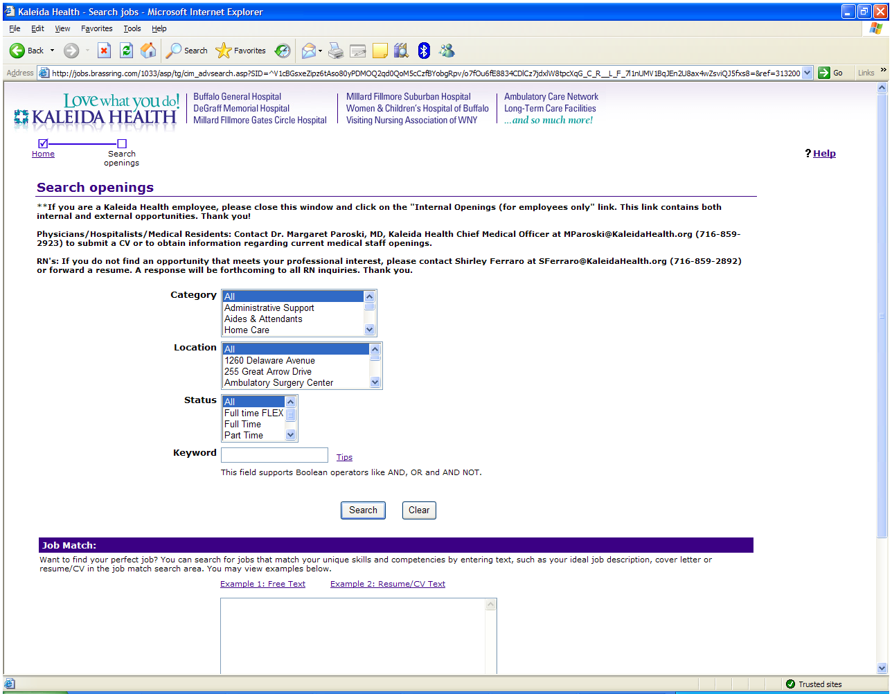

Highlight the category, location and status you prefer or enter a keyword. Then click ***Search***.

Check the box next to the job(s) of your interest. You can select up to 10 postings.

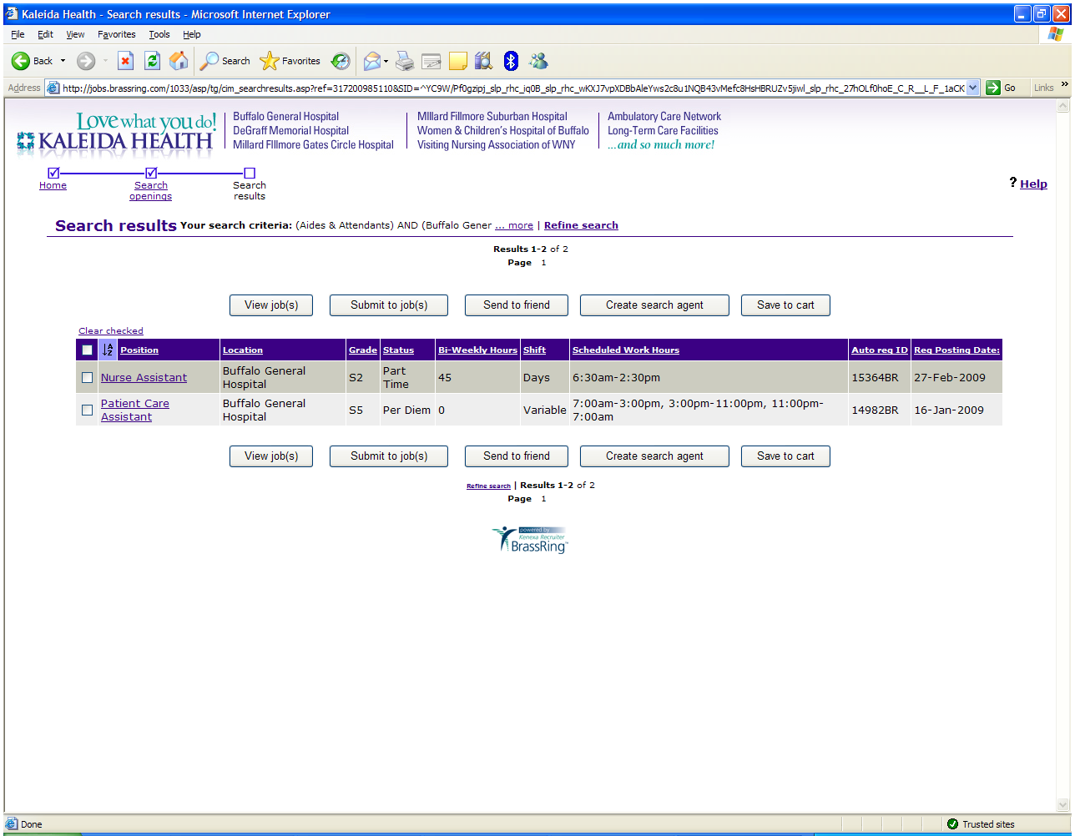

After you have made your selections, click ***Submit to job(s).***

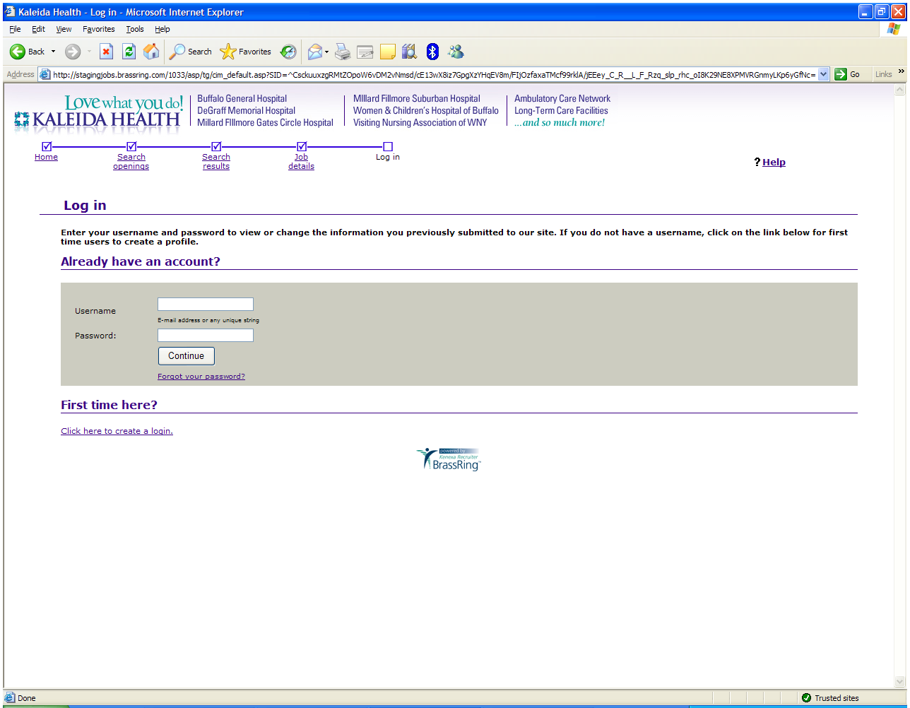

First time users, click this link to create a profile.

Choose a username and password you will remember so that you can update your profile at a later date.

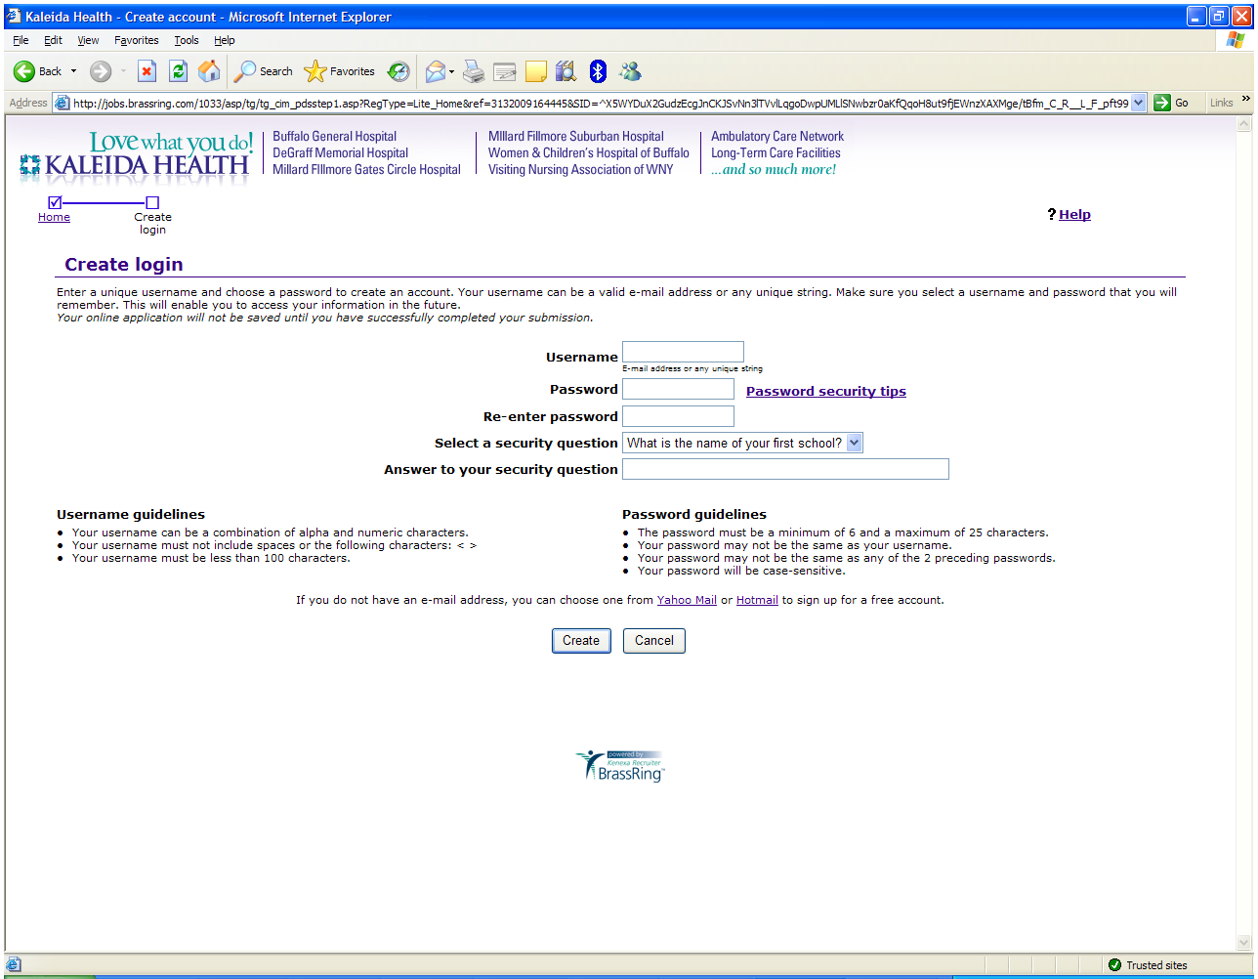

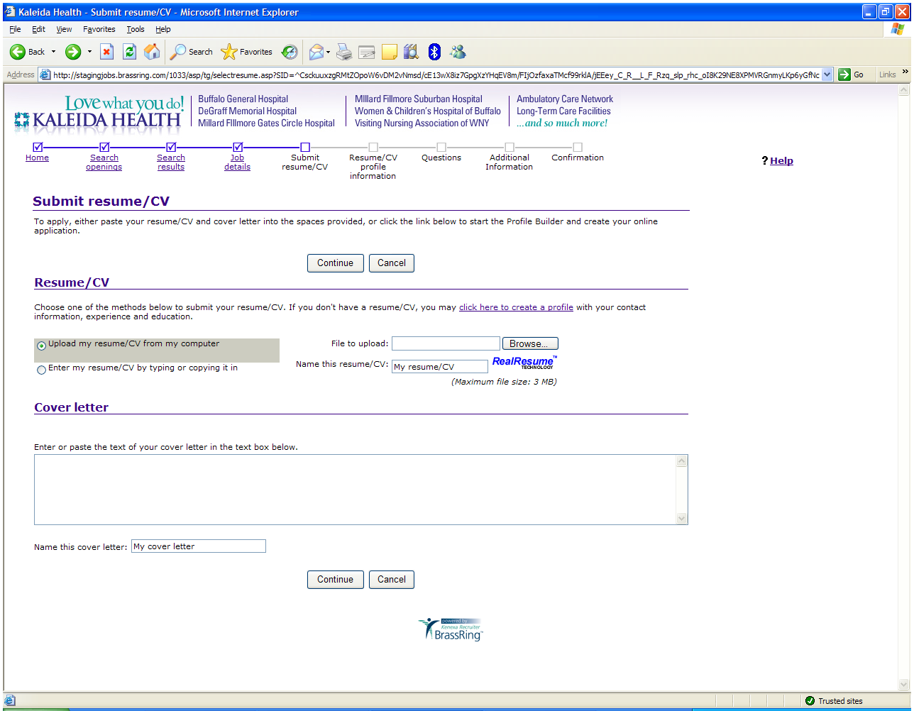

If you want to create a profile without a resume, click here.

If you have a resume to upload or cut & paste, click here.

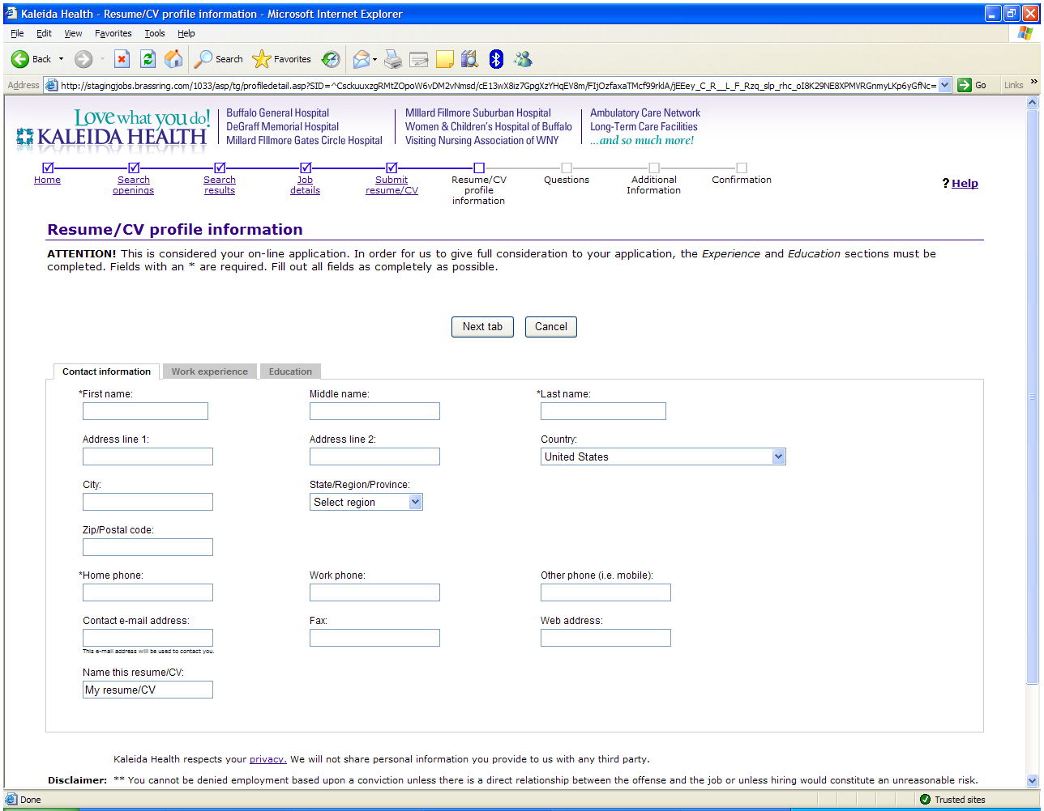

Verify all contact info is correct and then click the Work Experience tab.

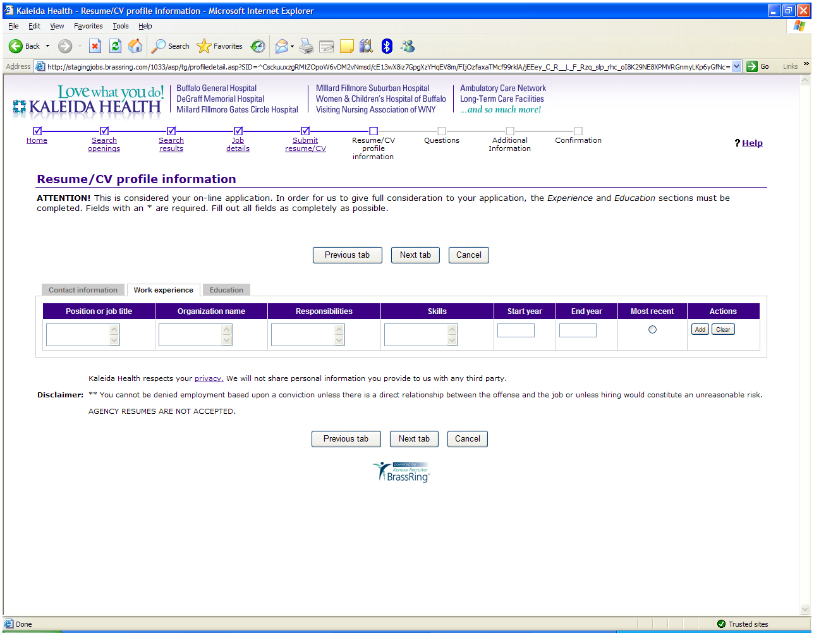

When all experience has been added, click the Education tab.

List all work experience by using the ***Add*** button.

List at least your most recent education. Use the ***Add*** button to include additional degrees.

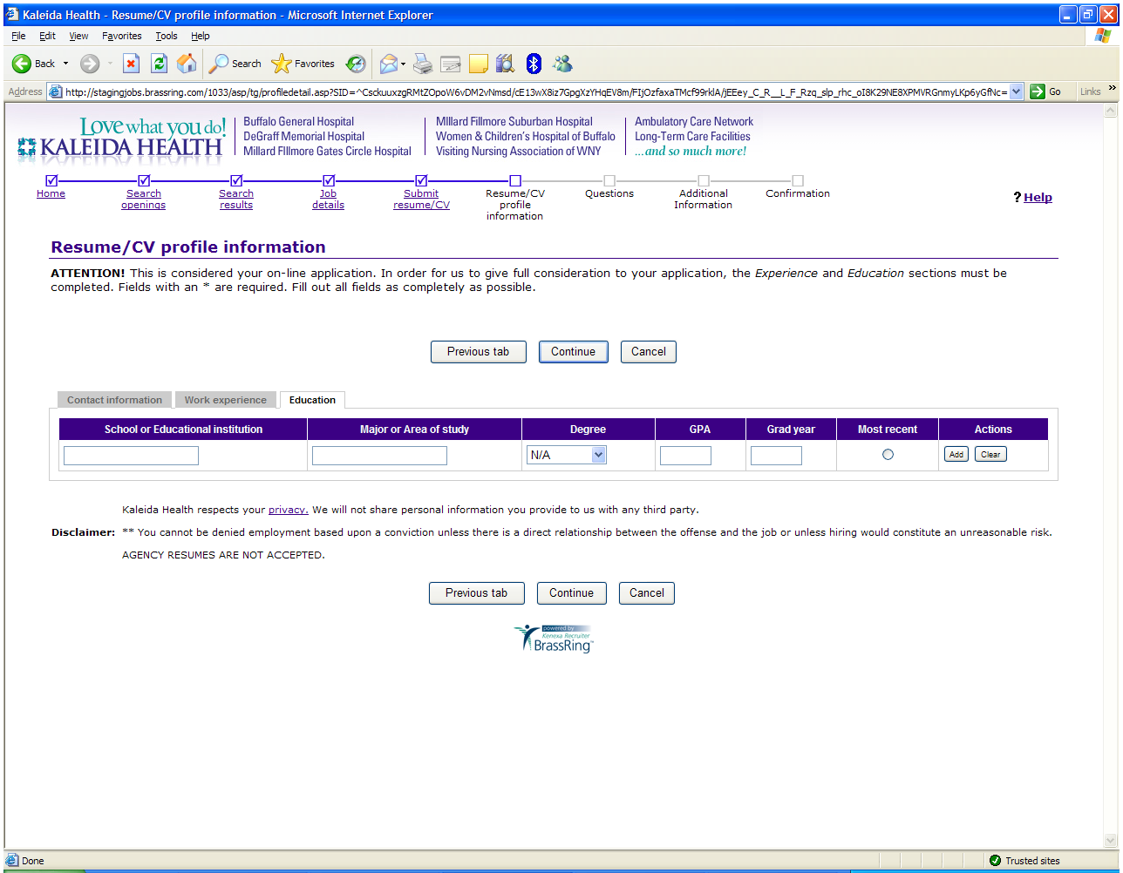

When complete, click ***Continue***.

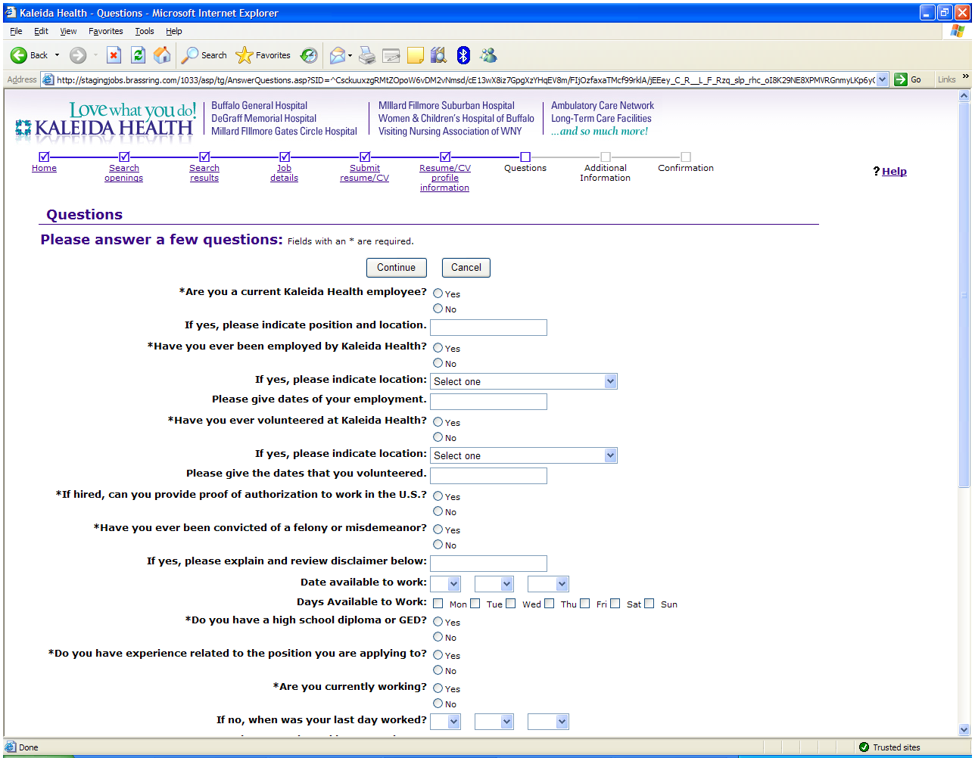

Complete the following questions. Click ***Continue*** when complete.

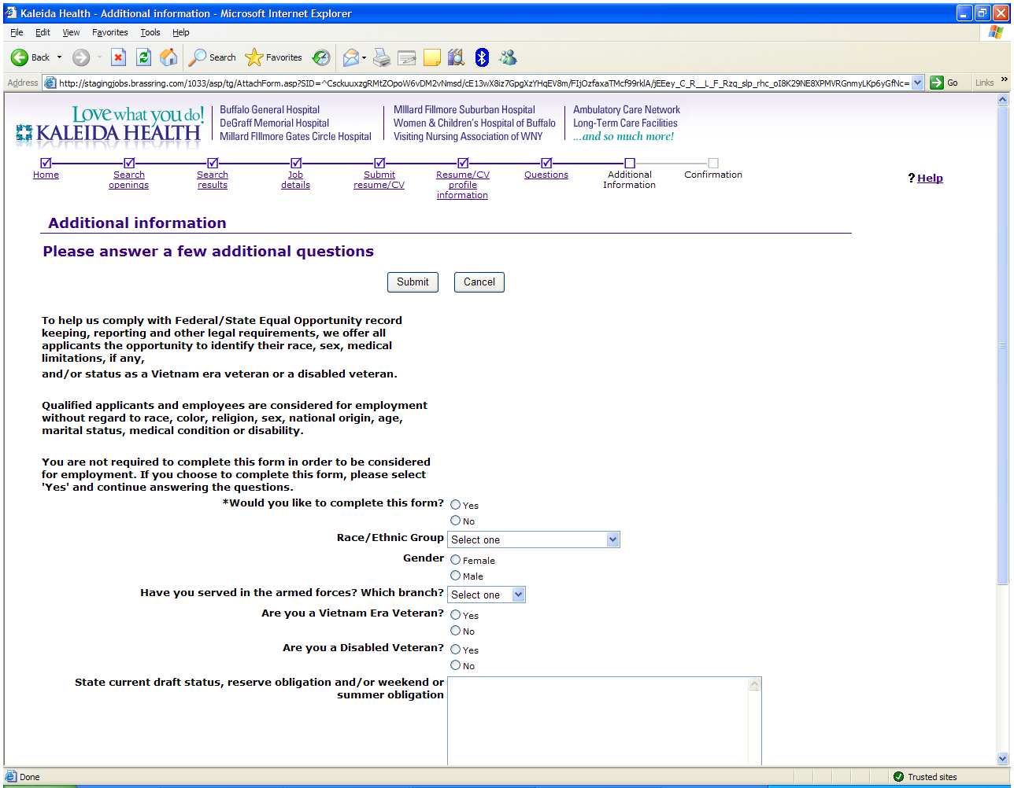

This form is optional. Click ***Yes*** and answer the following questions or click ***No*** and then ***Submit*** to continue.

