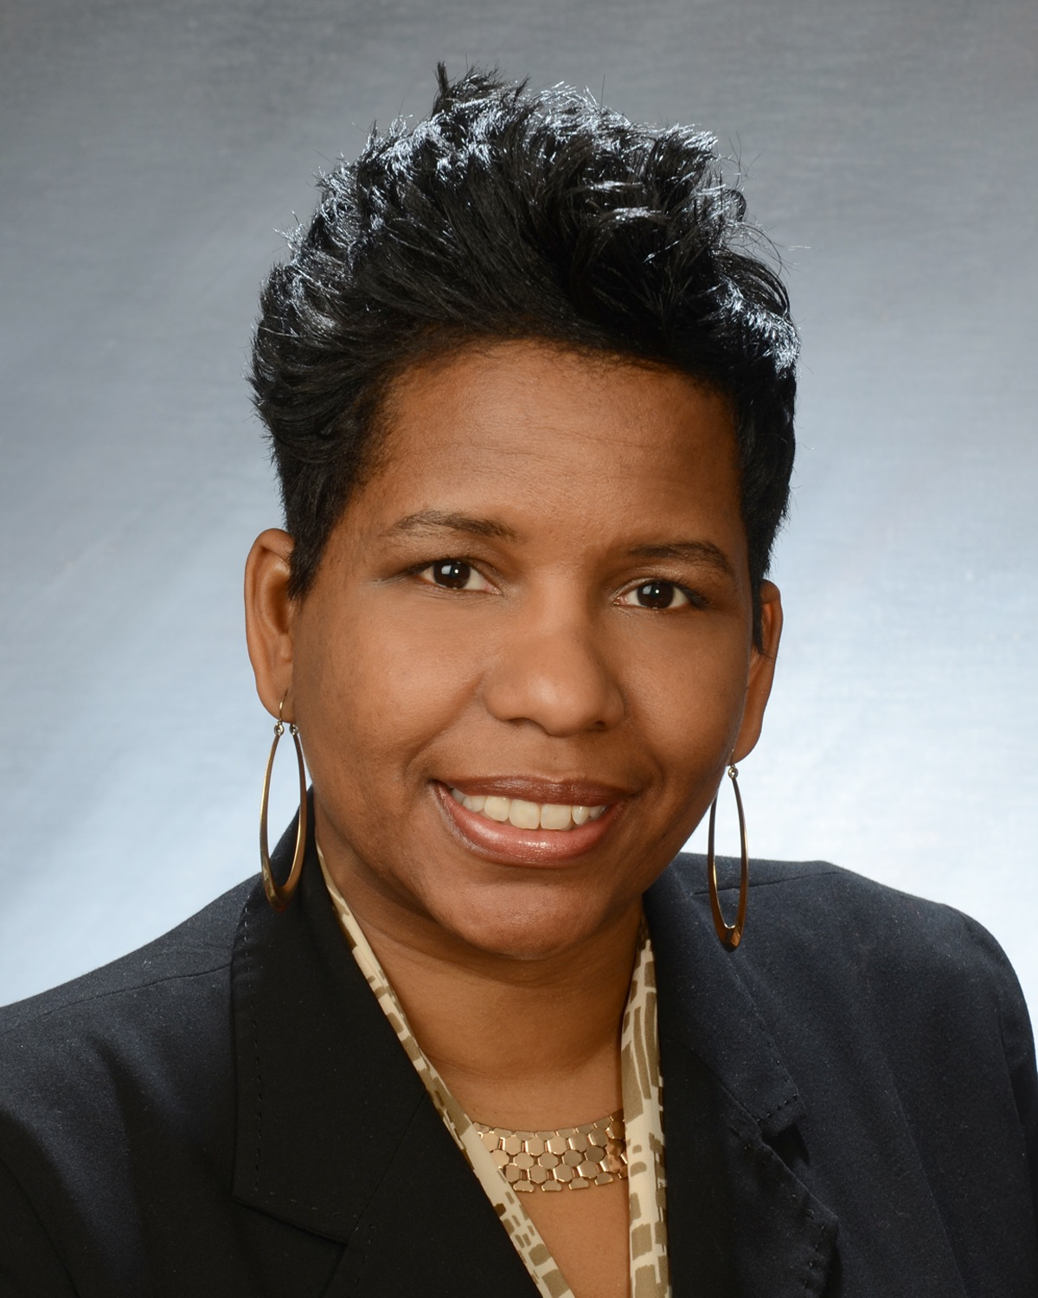

Born and raised in Buffalo, NY, Mia brings a wealth of knowledge with her as a Realtor. Mia has over 20 years of experience in customer service, problem solving and negotiations. She graduated from Buffalo State College with a degree in economics and Medaille College, with a Masters degree in Business Administration. With a passion for helping friends and family find that perfect house, it’s no wonder Mia finally chose a career in real estate.

With her engaging personality, Mia is known for her genuine concern as she creates a positive experience for both sides in any transaction. Her approach is direct and successful. She listens to each of her client needs and matches them to the perfect home.

Mia specializes in helping first-time homebuyers find their dream home. She has held numerous seminars to educate buyers on the entire process of buying a home and the many different grant programs that are available to assist with closing costs and down payments.

Mia volunteers at Ronald McDonald House, Buffalo City Mission and is actively involved in her church, Mount Olive Baptist Church. She credits her success to God, our heavenly father, because without him none of this would be possible. Also her supportive husband, Robert Mootry Jr. and daughter, Kayla Garrett.

